MIDDLE CLASS LESSON NOTES TERM I
LEARNING AREA 5 (READING)
Sound
Sat pin
c k m e d h
Copy the same
s a t i p n

g u b f k

Write the sound

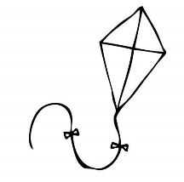

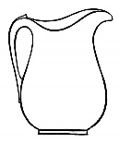
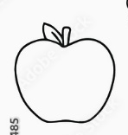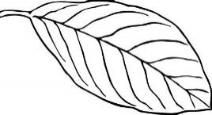

Match sound to picture
s 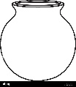
a 
p
g
Match
b 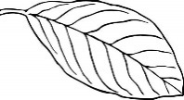

c 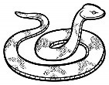

l 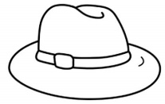

h

g

Match
d 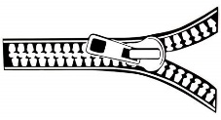
k 
z 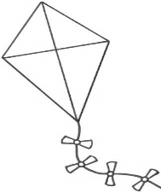
n 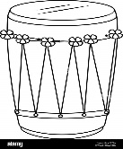
Draw for the sound
s | c | A | e
t | f | g
Vowel letters
a e i o u
Copy and write
a e i o u

Match and write
a u _______
e o _______
i a _______
o e _______
u i _______
Vowel words
at in an egg up am
it of off
Join and form words.
a-n = o – f = o n u p I n

Words
sun mat pot cup egg fan can tin
“a” sound syllables
ba ca fa ha ga ma la ra va na sa wa
ya za
Copy the same
ba ca da fa ga ha

Sound and read
ca-t wa-x ma-t ba-g
ya-m ca-n pa-n fa-n
NOTE: Join and form
ma-n = man

MIDDLE CLASS LESSON NOTES TERM I
WRITING

